**NOTE: This is an official document by Indexademics. Unless otherwise stated, this document may not be accredited to individuals or groups other than the club IDX, nor should this document be distributed, sold, or modified for personal use in any way.**

**IDX G9 PHYSICS S STUDY GUIDE ISSUE 5**

**By Virginia and Joyce**

Chapter 6 By Virginia

**Chapter 6: Motion in Two Dimensions**

**Section 6.1: Projectile Motion**

**Key Concepts:**

•Projectile Motion: An object moving through the air under the influence of gravity alone.

•Trajectory: The curved path followed by a projectile (parabolic in ideal cases).

•Forces Acting on a Projectile

•Only gravity acts on it (if air resistance is ignored).

•Independence of Motion

•Horizontal motion: Constant velocity.

•Vertical motion: Accelerated motion due to gravity.

**Formulas:**

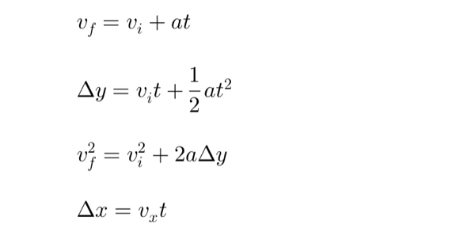

**Typical Projectile Motion Questions &Hints**

1. A stone is dropped from rest and falls for 8.0s. Find its velocity and displacement.

Steps to Solve:

(a) Find the velocity after 8.0s:

(b) Find the displacement during this time:

2. A projectile is launched horizontally from a height. Determine its time of flight and range.

Steps to Solve:

(a) Find the time of flight:

(b) Find the horizontal range:

3. “Monkey and Hunter Problem”: Where should the hunter aim?

Concept Explanation:

• The bullet and the monkey experience the same gravitational acceleration.

• Since both undergo the same vertical displacement, the hunter should aim directly at the monkey.

**Section 6.2: Circular Motion**

**Key Concepts:**

• Uniform Circular Motion (UCM): Movement at constant speed around a circle.

• Velocity: Always tangential to the circle.

• Acceleration: Always directed toward the center (centripetal acceleration).

• Centripetal Force: The net force required to keep an object moving in a circle.

**Formulas:**

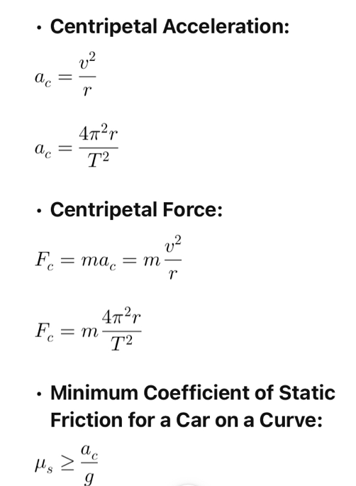

**Typical Circular Motion Questions &Hints**

4. A stopper is swung in a circle. Find the tension in the string.

Steps to Solve:

1. Find the velocity using the period equation:

2. Find the centripetal force:

3. Since the tension in the string provides the centripetal force:

5. A car moves around a curve. Find its centripetal acceleration and required friction coefficient.

Steps to Solve:

(a) Find the centripetal acceleration:

(b) Find the minimum coefficient of static friction:

6. A passenger in a turning car feels pushed outward—explain why.

Concept Explanation:

• There is no actual outward force; this is an inertial effect due to the passenger’s resistance to changing motion.

• The car applies a friction force inward to keep the passenger moving in a circle.

**Steps to Explain:**

1. Draw the free-body diagram: Show forces acting on the passenger.

2. Identify the real force: The inward force (friction from the seat or door) keeps the passenger moving in a circle.

3. Explain the sensation: The body wants to continue in a straight line (Newton’s 1st Law), making it feel like an outward force is acting.

**Most Important: Centrifugal force is not real**